STAT2003 ASSIGNMENT 1

Comparison of Machine Learning Algorithms  
Nina Kumagai (19389905) and Amanda Efendi (19488187)

# Part 1.1 Design of Experiment

|  |  |
| --- | --- |
| **Factors** | Types of Machine Learning algorithm |
| **Levels of each factor** | 5 levels (Logistic Regression, Linear Discriminant Analysis, Classification and Regression Trees, Naïve Bayes, Support Vector Machines) |
| **Experimental Unit** | Each prediction run on a test set by a single algorithm trained with the corresponding training set |
| **Response** | The accuracy of the predictions made by each algorithm |
| **Number of Replications** | 10. To provide more than 30 observations across all levels to achieve normality of residuals |
| **Experimental Methodology** | Using multiple random sampling seeds, the main dataset is re-sampled into 10 different sets of training and testing sets. Each machine learning algorithm is run on 10 different training sets (10 replicates), and the number of correct predictions is recorded for each replicate. This number is then converted into an accuracy percentage and listed in a longform with the type of machine learning algorithm as their grouping. |

# Part 1.2 Principles of Design

**Randomisation** is applied by the use of the sample() function in selecting the training and testing subset. Using the set.seed() function, we are able to generate 10 sets of random indexes.

**Replication** is achieved by generating 10 sets of different training and testing subsets of the data frame. Each Machine Learning algorithms are trained and tested on each set as a replicate. This results in 10 replicates of each machine learning algorithm

**Blocking** was not applied. According to the UCI site, there were no information on whether or not blocking was used in collecting the banknotes.

# Part 2. EDA Graphs

|  |  |
| --- | --- |
|  |  |
|  |  |

The banknote dataset has 4 variables along with the classification variable called class. As seen from above, the values for kurtosis and entropy are skewed, while the variance and skew are slightly normal with several peaks. Among the 1372 rows of data, 762 are fake and 610 are real.

|  |
| --- |
| ## variance skew kurtosis entropy  ## Min. :-7.0421 Min. :-13.773 Min. :-5.2861 Min. :-8.5482  ## 1st Qu.:-1.7730 1st Qu.: -1.708 1st Qu.:-1.5750 1st Qu.:-2.4135  ## Median : 0.4962 Median : 2.320 Median : 0.6166 Median :-0.5867  ## Mean : 0.4337 Mean : 1.922 Mean : 1.3976 Mean :-1.1917  ## 3rd Qu.: 2.8215 3rd Qu.: 6.815 3rd Qu.: 3.1793 3rd Qu.: 0.3948  ## Max. : 6.8248 Max. : 12.952 Max. :17.9274 Max. : 2.4495 |

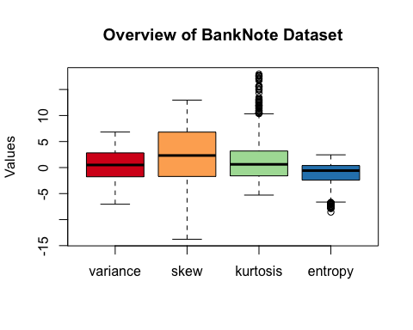

# Part 3. Findings

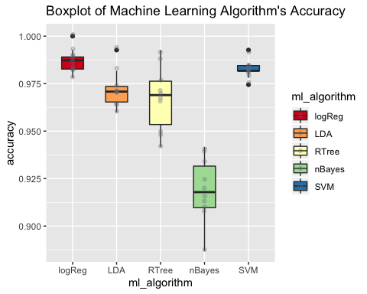

The boxplot above shows the accuracy of each machine learning algorithm over 10 replicates. The accuracy is obtained by adding up the correct (true negative and true positive) predictions and divided by the total number of observations in the test subset.

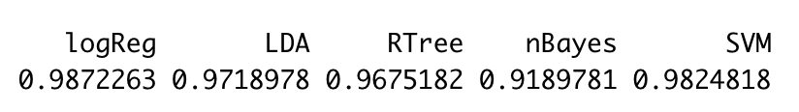

Results of analysis are reported as follows: Mean (standard deviation) of machine learning models for logistic regression, linear discriminant analysis, regression tree, naive bayes and support vector machine are 0.989(0.006), 0.9777(0.010), 0.9660(0.0115), 0.9124(0.0122), 0.985(0.0085) respectively. As seen on the table above, Logistic Regression and Support Vector Machine have the two highest mean accuracy compared to the other algorithms. The boxplot also indicates that logistic regression and support vector machine algorithm are also consistent with their findings. In contrast, Naïve Bayes, Classification and Regression Trees has a larger variety in their accuracy.

## Df Sum Sq Mean Sq F value Pr(>F)   
## ml_algorithm 4 0.03887 0.009717 97.47 <2e-16 ***  
## Residuals 45 0.00449 0.000100  
## ---  
## Signif. codes: 0 '***' 0.001 '**' 0.01 '*' 0.05 '.' 0.1 ' ' 1

The results of the analysis of variance indicates that at 5% level of significance there is sufficient evidence (F(4,45)=97.47, P= 2x10-16) to conclude that average accuracy of machine learning models is not the same across model types.

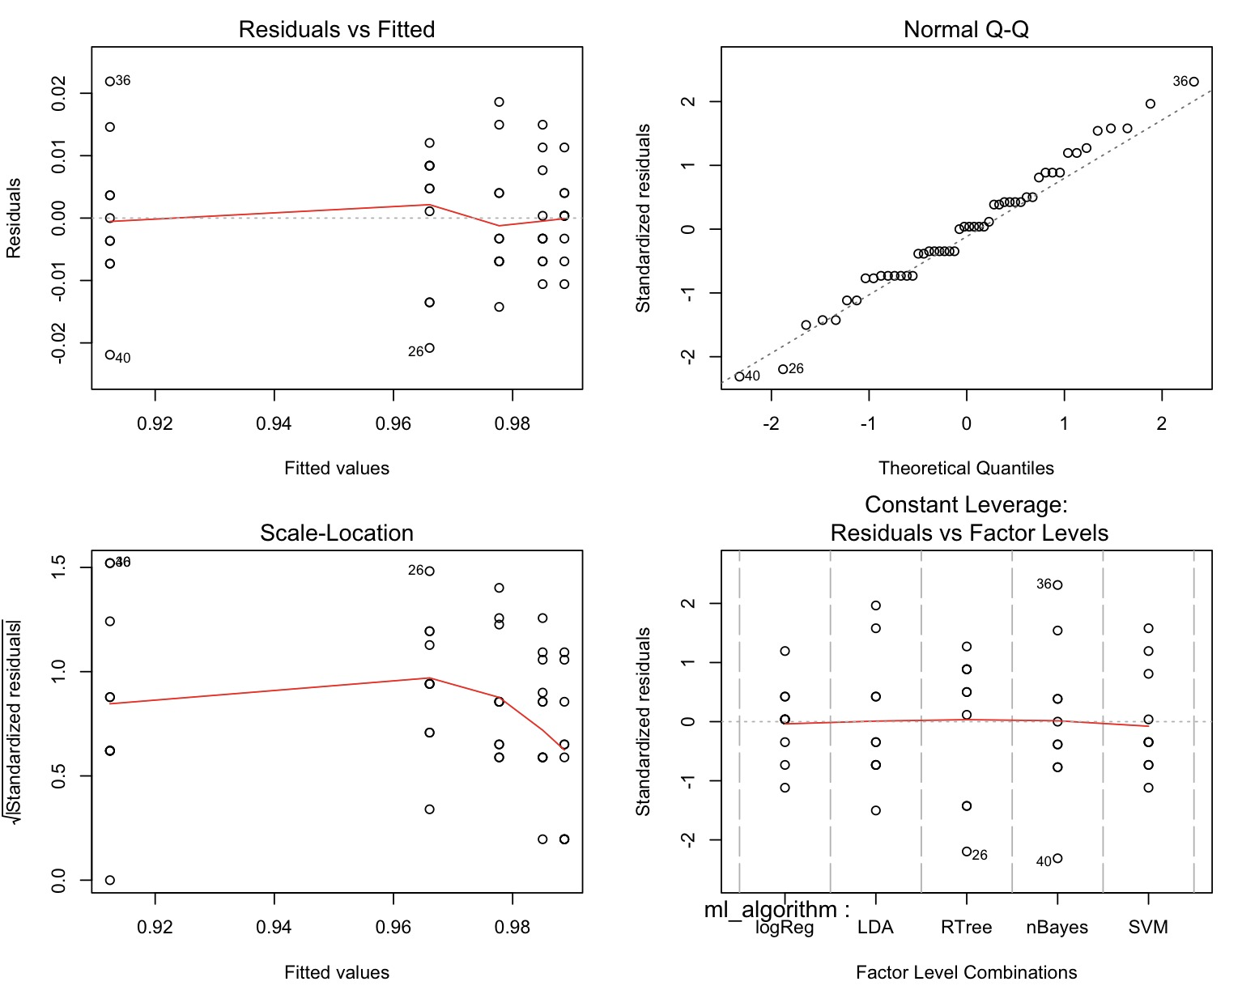

A further examination of the residuals of the ANOVA can be seen below.

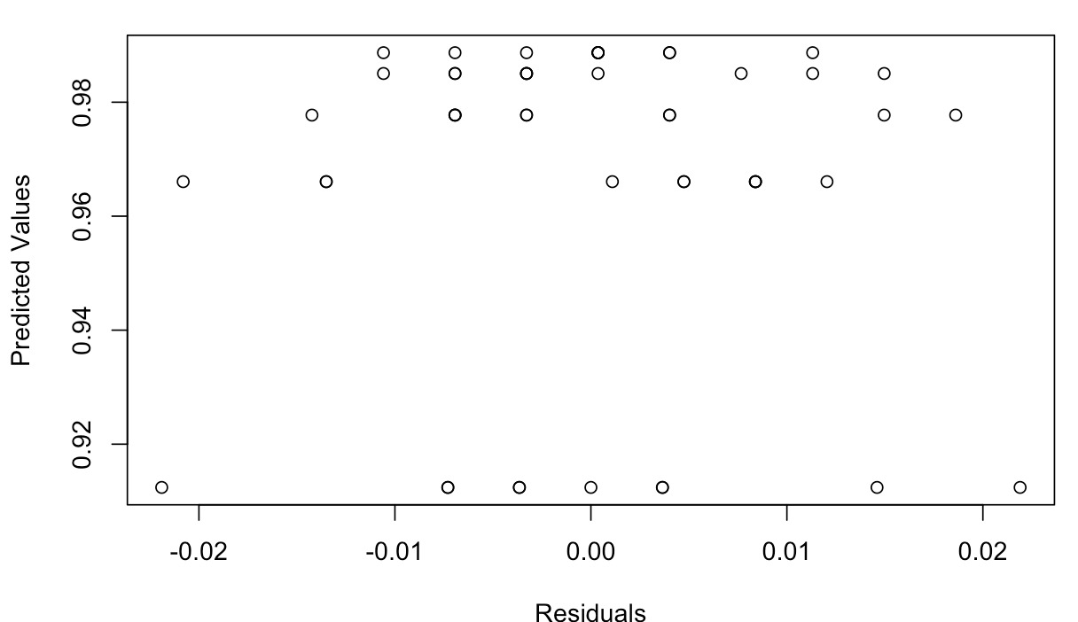

Plot of residuals against predicted values does not show any unusual pattern (funneling or

bow shape). As normality was valid (Shapiro Wilk, P=0.7921), Bartlett test results are reliable. Bartlett test lead to high P-value (P=0.3147), indicating equality of variance in residuals across factor levels (homogeneity). Levene’s test also leads to the similar result but with slightly higher p-value (p = 0.5845). Finally, as the order experiment was random with reference to each factor level setting, independence of errors can be assumed.

|  |
| --- |
| ## $groups ## accuracy groups ## logReg 0.9872263 a ## SVM 0.9824818 ab ## LDA 0.9718978 bc ## RTree 0.9675182 c ## nBayes 0.9189781 d |

For Post-Hoc Comparison Pairwise Test, the Tukey’s LSD test shows 4 distinct groups within the levels of treatment. Logistic Regression is considered different to Linear Discriminant Analysis, RTree and Naïve Bayes, while it is the same as Support Vector Machine. While Naïve Bayes, is considered the most distinct from other treatments.

# Part 4. Limitations

The bank notes dataset was obtained from the UCI website. There was no information on the process undertaken to collect the data. Thus, randomisation in selecting the bank notes had to be assumed to enable the use of the dataset. The website didn’t provide any information regarding any blocking that the owners of the dataset might have done while collecting the data. An example of blocking that could have been done is grouping the notes based on the country of origin.

The banknotes data is then re-sampled into 10 sets of training and testing subsets for the machine learning algorithms. To improve the accuracy of the comparison by assuming normality, more than 10 re-samples of the dataset could have been applied.

Limited understanding of each machine learning algorithms could also impact the interpretation of the results. Perhaps one machine learning algorithm are only more sensitive to large sample sizes, thus resulting in an inaccurate portrayal of its performance in this experiment.

# Part 5. Application to other classification problems

As mentioned above, each machine learning algorithm requires different assumption. Logistic Regression performed well in classifying the bank notes, however, if we changed the dataset, it might be a different case. On the other hand, other model may perform better. For example, Naïve Bayes assumes that each variable in a class is independent to all the other variables within that class (Sidana, 2017). In our dataset, the Naïve Bayes performed poorly compared to the other classification algorithms due to the banknote dataset’s variables such as variance and skew that are known to be dependent of each other. Due to these reasons, the results from Naïve Bayes will change with a different dataset.

# Reference:

Sidana, M. (2017, Feb 28). Types of Classification Algorithms in Machine Learning [Blog post]. Retrieved from <https://medium.com/@Mandysidana/machine-learning-types-of-classification-9497bd4f2e14>.

# Appendices

# 1. Loading the data

df = read.table("data_banknote_authentication.txt",  
 sep=",",  
 col.names=c("variance", "skew", "kurtosis", "entropy", "class"),  
 fill=FALSE,   
 strip.white=TRUE)

# 2. Data Wrangling

head(df)

## variance skew kurtosis entropy class  
## 1 3.62160 8.6661 -2.8073 -0.44699 0  
## 2 4.54590 8.1674 -2.4586 -1.46210 0  
## 3 3.86600 -2.6383 1.9242 0.10645 0  
## 4 3.45660 9.5228 -4.0112 -3.59440 0  
## 5 0.32924 -4.4552 4.5718 -0.98880 0  
## 6 4.36840 9.6718 -3.9606 -3.16250 0

summary(df)

## variance skew kurtosis entropy   
## Min. :-7.0421 Min. :-13.773 Min. :-5.2861 Min. :-8.5482   
## 1st Qu.:-1.7730 1st Qu.: -1.708 1st Qu.:-1.5750 1st Qu.:-2.4135   
## Median : 0.4962 Median : 2.320 Median : 0.6166 Median :-0.5867   
## Mean : 0.4337 Mean : 1.922 Mean : 1.3976 Mean :-1.1917   
## 3rd Qu.: 2.8215 3rd Qu.: 6.815 3rd Qu.: 3.1793 3rd Qu.: 0.3948   
## Max. : 6.8248 Max. : 12.952 Max. :17.9274 Max. : 2.4495   
## class   
## Min. :0.0000   
## 1st Qu.:0.0000   
## Median :0.0000   
## Mean :0.4446   
## 3rd Qu.:1.0000   
## Max. :1.0000

#library(dlookr)  
#describe_data = describe(df)

#Change class to factor  
df$class <- as.factor(df$class); str(df)

## 'data.frame': 1372 obs. of 5 variables:  
## $ variance: num 3.622 4.546 3.866 3.457 0.329 ...  
## $ skew : num 8.67 8.17 -2.64 9.52 -4.46 ...  
## $ kurtosis: num -2.81 -2.46 1.92 -4.01 4.57 ...  
## $ entropy : num -0.447 -1.462 0.106 -3.594 -0.989 ...  
## $ class : Factor w/ 2 levels "0","1": 1 1 1 1 1 1 1 1 1 1 ...

#Rename the levels of class  
levels(df$class) <- c("Fake", "Real"); str(df)

## 'data.frame': 1372 obs. of 5 variables:  
## $ variance: num 3.622 4.546 3.866 3.457 0.329 ...  
## $ skew : num 8.67 8.17 -2.64 9.52 -4.46 ...  
## $ kurtosis: num -2.81 -2.46 1.92 -4.01 4.57 ...  
## $ entropy : num -0.447 -1.462 0.106 -3.594 -0.989 ...  
## $ class : Factor w/ 2 levels "Fake","Real": 1 1 1 1 1 1 1 1 1 1 ...

# 3. EDA on Data

library(RColorBrewer)  
boxplot(df[,1:4], ylab='Values', main='Overview of BankNote Dataset', col=c(brewer.pal(4, "Spectral")))



library(DescTools)  
plot(Desc(df))

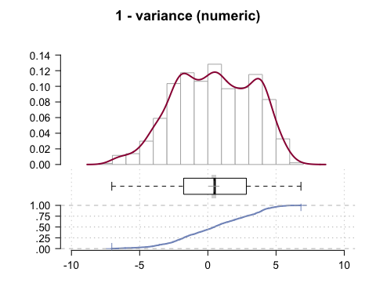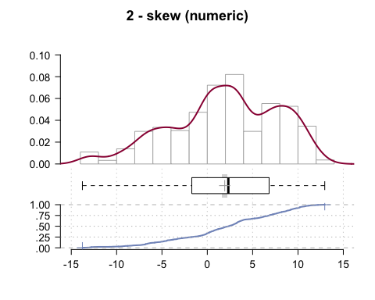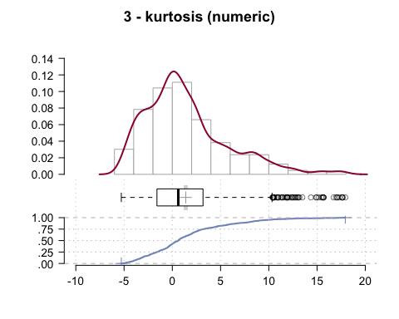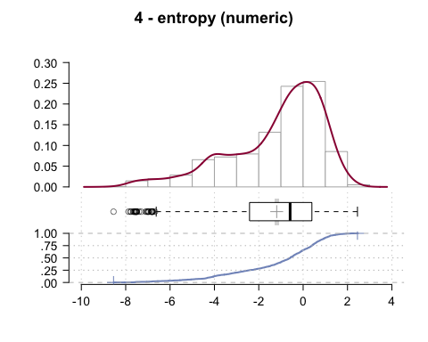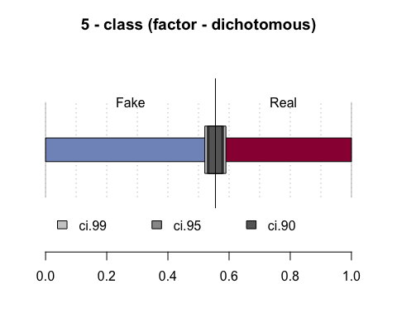

#hist(df)

plot(df)

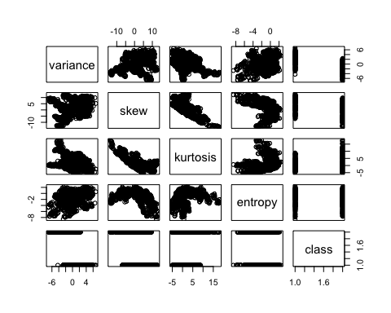

library(DataExplorer)

# 4. Making TRAINING and TESTING subsets

make_train = function(seed_no){  
 set.seed(seed_no)  
 testIdx <- sample(1:nrow(df),floor(nrow(df)*0.2))  
 training <- df[-testIdx,]  
 return (training)  
}

make_test = function(seed_no){  
 set.seed(seed_no)  
 testIdx <- sample(1:nrow(df),floor(nrow(df)*0.2))  
 testing <- df[testIdx,]  
 return (testing)  
}

train1 = make_train(79)  
test1 = make_test(79)  
  
train2 = make_train(8)  
test2 = make_test(8)  
  
train3 = make_train(19)  
test3 = make_test(19)  
  
train4 = make_train(23)  
test4 = make_test(23)  
  
train5 = make_train(32)  
test5 = make_test(32)  
  
train6 = make_train(75)  
test6 = make_test(75)  
  
train7 = make_train(102)  
test7 = make_test(102)  
  
train8 = make_train(421)  
test8 = make_test(421)  
  
train9 = make_train(792)  
test9 = make_test(792)  
  
train10 = make_train(1)  
test10 = make_test(1)

# 5. MACHINE LEARNING ALGORITHMS

## TREATMENT: Level 1 Logistic Regression

library(pROC)

## Type 'citation("pROC")' for a citation.

##   
## Attaching package: 'pROC'

## The following objects are masked from 'package:stats':  
##   
## cov, smooth, var

logreg = function(training, testing){  
 glm = glm(class ~ . , data = training, family = binomial(link="logit"))  
 # summary(glm)  
 pred.glm = predict(glm, newdata=testing, type='response')  
 pred.glmclass = rep("Fake", length(pred.glm))  
 pred.glmclass[pred.glm>0.5] = "Real"  
 # table(pred.glmclass, test1$class, dnn=c("Predictions","Actual"))  
 tn = table(pred.glmclass, testing$class, dnn=c("Predictions","Actual"))[1,1]  
 tp = table(pred.glmclass, testing$class, dnn=c("Predictions","Actual"))[2,2]  
 accuracy = (tn + tp)/nrow(testing)  
 return (accuracy)  
}

logreg_df = data.frame(accuracy = c(logreg(train1, test1), logreg(train2, test2), logreg(train3, test3), logreg(train4, test4), logreg(train5, test5), logreg(train6, test6), logreg(train7, test7), logreg(train8, test8), logreg(train9, test9), logreg(train10, test10)),  
 ml_algorithm = rep("logReg", 10))

logreg_df

## accuracy ml_algorithm  
## 1 0.9854015 logReg  
## 2 0.9854015 logReg  
## 3 0.9927007 logReg  
## 4 1.0000000 logReg  
## 5 0.9781022 logReg  
## 6 0.9817518 logReg  
## 7 0.9890511 logReg  
## 8 0.9817518 logReg  
## 9 0.9890511 logReg  
## 10 0.9890511 logReg

par(pty='s')  
glm = glm(class ~ . , data = train1, family = binomial(link="logit"))

## Warning: glm.fit: fitted probabilities numerically 0 or 1 occurred

pred.glm = predict(glm, newdata=test1, type='response')  
plot(roc(test1$class, pred.glm), legacy.axes=TRUE)

## Setting levels: control = Fake, case = Real

## Setting direction: controls < cases

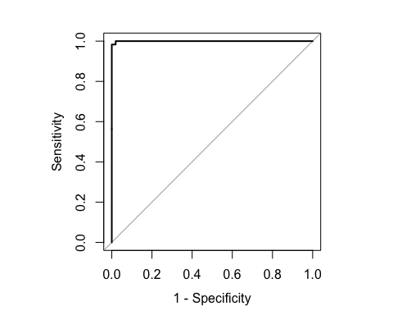

## TREATMENT: Level 2 Linear Discriminant Analysis

library(MASS)  
ldareg <- function(training, testing){  
 lda_fit = lda(class ~ . , data=training)  
 lda_pred = predict(lda_fit, newdata=testing)  
 accuracy = sum(table(testing$class, lda_pred$class)[1,1],table(testing$class, lda_pred$class)[2,2])/nrow(testing)  
 return(accuracy)  
}

lda_df = data.frame(accuracy = c(ldareg(train1, test1), ldareg(train2, test2), ldareg(train3, test3), ldareg(train4, test4), ldareg(train5, test5), ldareg(train6, test6), ldareg(train7, test7), ldareg(train8, test8), ldareg(train9, test9), ldareg(train10, test10)),   
 ml_algorithm = rep("LDA",5))  
  
lda_df

## accuracy ml_algorithm  
## 1 0.9817518 LDA  
## 2 0.9635036 LDA  
## 3 0.9927007 LDA  
## 4 0.9708029 LDA  
## 5 0.9635036 LDA  
## 6 0.9598540 LDA  
## 7 0.9708029 LDA  
## 8 0.9708029 LDA  
## 9 0.9708029 LDA  
## 10 0.9744526 LDA

## TREATMENT: Level 3 Classification and Regression Trees

library(rpart)  
rpart = rpart(class ~ ., data = train1)  
plot(rpart)  
text(rpart)

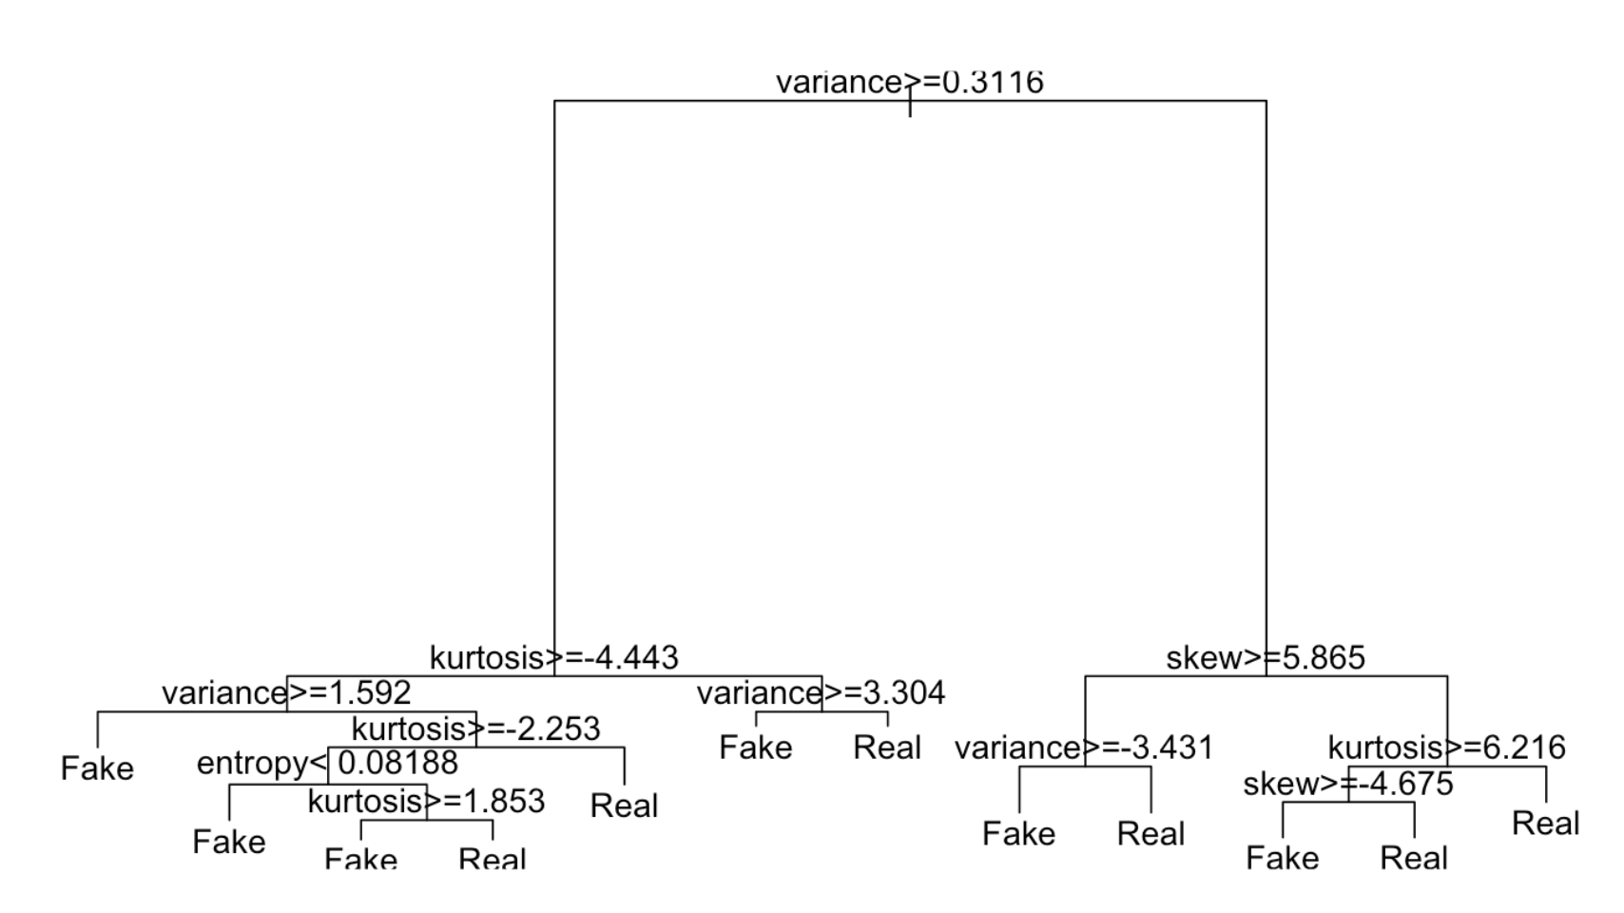

library(partykit)

plot(as.party(rpart))

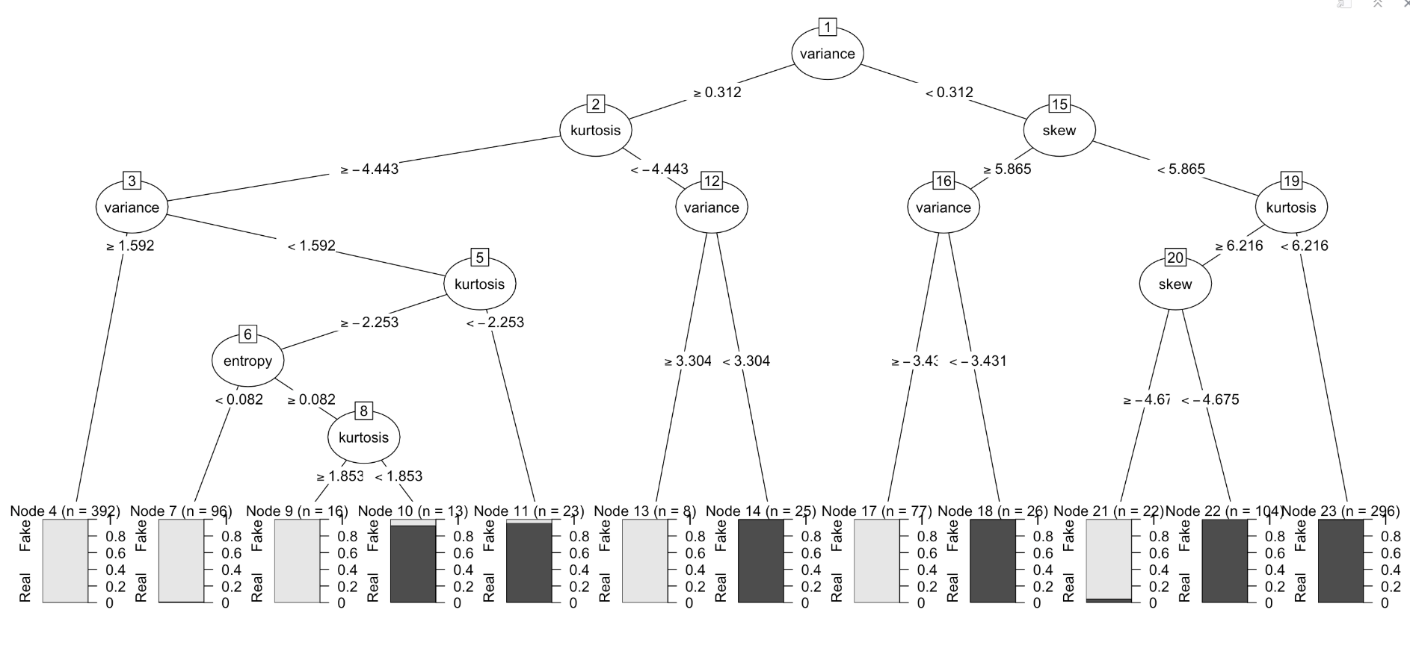

regtree = function(training, testing){  
 rpart = rpart(class ~ ., data = training)  
 rpart.pred = predict(rpart, newdata = testing, type = "class")  
 tn = table(rpart.pred, testing$class, dnn = c("Prediction", "Actual"))[1,1]  
 tp = table(rpart.pred, testing$class, dnn = c("Prediction", "Actual"))[2,2]  
 accuracy = (tn + tp)/nrow(testing)  
 return (accuracy)  
}

regtree_df = data.frame(accuracy = c(regtree(train1, test1), regtree(train2, test2), regtree(train3, test3), regtree(train4, test4), regtree(train5, test5), regtree(train6, test6), regtree(train7, test7), regtree(train8, test8), regtree(train9, test9), regtree(train10, test10)),   
 ml_algorithm = rep("RTree", 5))  
  
regtree_df

## accuracy ml_algorithm  
## 1 0.9927007 RTree  
## 2 0.9671533 RTree  
## 3 0.9416058 RTree  
## 4 0.9781022 RTree  
## 5 0.9708029 RTree  
## 6 0.9489051 RTree  
## 7 0.9489051 RTree  
## 8 0.9671533 RTree  
## 9 0.9708029 RTree  
## 10 0.9890511 RTree

## TREATMENT: Level 4 Naive Bayes

library(naivebayes)

## naivebayes 0.9.6 loaded

nBayes = function(training, testing){  
 nb = naive_bayes(class ~ .,usekernel=T, data=training)  
 nb.pred=predict(nb, newdata = testing, type="class")  
 tn = table(nb.pred, testing$class, dnn = c("Prediction", "Actual"))[1,1]  
 tp = table(nb.pred, testing$class, dnn = c("Prediction", "Actual"))[2,2]  
 accuracy = (tn + tp)/nrow(testing)  
 return (accuracy)  
}

nbayes_df = data.frame(accuracy = c(nBayes(train1, test1), nBayes(train2, test2), nBayes(train3, test3), nBayes(train4, test4), nBayes(train5, test5), nBayes(train6, test6), nBayes(train7, test7), nBayes(train8, test8), nBayes(train9, test9), nBayes(train10, test10)),   
 ml_algorithm = rep("nBayes", 5))

nbayes_df

## accuracy ml_algorithm  
## 1 0.9197080 nBayes  
## 2 0.9233577 nBayes  
## 3 0.9160584 nBayes  
## 4 0.9416058 nBayes  
## 5 0.9379562 nBayes  
## 6 0.9343066 nBayes  
## 7 0.9124088 nBayes  
## 8 0.9087591 nBayes  
## 9 0.9087591 nBayes  
## 10 0.8868613 nBayes

## TREATMENT: Level 5 Support Vector Machines

# Fitting SVM to the Training set   
library(e1071)

svm_func = function(train, testing){  
 # svm_fit = svm(formula = class ~ ., data = training, type = 'C-classification', kernel = 'linear')  
 training = train  
 svm_fit = svm(formula = class ~ ., data = training, kernel = "linear")  
 svm.pred = predict(svm_fit, newdata = testing, type = "class")   
 tn = table(svm.pred, testing$class, dnn = c("Prediction", "Actual"))[1,1]  
 tp = table(svm.pred, testing$class, dnn = c("Prediction", "Actual"))[2,2]  
 # tn = table(testing[,5], svm_pred)[1,1]  
 # tp = table(testing[,5], svm_pred)[2,2]  
 accuracy = (tn + tp)/nrow(testing)  
 return (accuracy)  
}

svm_df = data.frame(accuracy = c(svm_func(train1, test1), svm_func(train2, test2), svm_func(train3, test3), svm_func(train4, test4), svm_func(train5, test5), svm_func(train6, test6), svm_func(train7, test7), svm_func(train8, test8), svm_func(train9, test9), svm_func(train10, test10)),   
 ml_algorithm = rep("SVM", 5))  
  
svm_df

## accuracy ml_algorithm  
## 1 0.9817518 SVM  
## 2 0.9817518 SVM  
## 3 0.9927007 SVM  
## 4 0.9854015 SVM  
## 5 0.9744526 SVM  
## 6 0.9817518 SVM  
## 7 0.9854015 SVM  
## 8 0.9817518 SVM  
## 9 0.9817518 SVM  
## 10 0.9781022 SVM

# FINAL DATASET OF EACH MODEL'S ACCURACY  
  
models_df = rbind(logreg_df, lda_df, regtree_df, nbayes_df, svm_df)  
models_df

## accuracy ml_algorithm  
## 1 0.9854015 logReg  
## 2 0.9854015 logReg  
## 3 0.9927007 logReg  
## 4 1.0000000 logReg  
## 5 0.9781022 logReg  
## 6 0.9817518 logReg  
## 7 0.9890511 logReg  
## 8 0.9817518 logReg  
## 9 0.9890511 logReg  
## 10 0.9890511 logReg  
## 11 0.9817518 LDA  
## 12 0.9635036 LDA  
## 13 0.9927007 LDA  
## 14 0.9708029 LDA  
## 15 0.9635036 LDA  
## 16 0.9598540 LDA  
## 17 0.9708029 LDA  
## 18 0.9708029 LDA  
## 19 0.9708029 LDA  
## 20 0.9744526 LDA  
## 21 0.9927007 RTree  
## 22 0.9671533 RTree  
## 23 0.9416058 RTree  
## 24 0.9781022 RTree  
## 25 0.9708029 RTree  
## 26 0.9489051 RTree  
## 27 0.9489051 RTree  
## 28 0.9671533 RTree  
## 29 0.9708029 RTree  
## 30 0.9890511 RTree  
## 31 0.9197080 nBayes  
## 32 0.9233577 nBayes  
## 33 0.9160584 nBayes  
## 34 0.9416058 nBayes  
## 35 0.9379562 nBayes  
## 36 0.9343066 nBayes  
## 37 0.9124088 nBayes  
## 38 0.9087591 nBayes  
## 39 0.9087591 nBayes  
## 40 0.8868613 nBayes  
## 41 0.9817518 SVM  
## 42 0.9817518 SVM  
## 43 0.9927007 SVM  
## 44 0.9854015 SVM  
## 45 0.9744526 SVM  
## 46 0.9817518 SVM  
## 47 0.9854015 SVM  
## 48 0.9817518 SVM  
## 49 0.9817518 SVM  
## 50 0.9781022 SVM

# SET DATAFRAME DATATYPE AS NUMERIC AND FACTOR  
models_df$accuracy = as.numeric(models_df$accuracy)  
models_df$ml_algorithm = as.factor(models_df$ml_algorithm)

boxplot(accuracy~ml_algorithm, xlab="ml_algorithm", ylab="Accuracy", main="Comparision of Accuracy of Machine Learning Models",data=models_df)

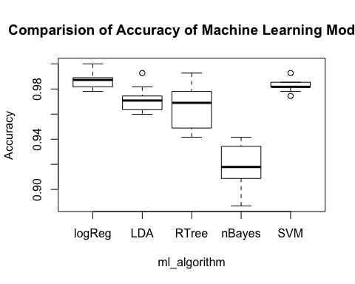

# 6. ANOVA Summary

ml_anova = aov(accuracy~ml_algorithm,data=models_df)  
summary(ml_anova)

## Df Sum Sq Mean Sq F value Pr(>F)   
## ml_algorithm 4 0.03887 0.009717 97.47 <2e-16 ***  
## Residuals 45 0.00449 0.000100  
## ---  
## Signif. codes: 0 '***' 0.001 '**' 0.01 '*' 0.05 '.' 0.1 ' ' 1

**Conclusion** Analysis of variance indicates that at 5% level of significance there is sufficient evidence (F(4,45)=97.47, P= < 2x10^-16) to conclude that average accuracy of machine learning models is not the same across model types.

## ANOVA Assumptions

opar <- par(mfrow=c(2,2),cex=.8)  
plot(ml_anova)



# follow through from above  
# comparing residuals and fitted values of anova  
ml_res <-residuals(ml_anova)  
ml_pre <-predict(ml_anova)

# Check for Normality of Residuals using Histogram and Boxplot  
par(mfrow=c(2,2))  
hist(ml_res, xlab="Residuals: ANOVA for Machine Learning Models ", main="Histogram of  
Residuals")  
boxplot(ml_res, ylab="Residuals: ANOVA for Machine Learning Models", main="Boxplot of Residuals")

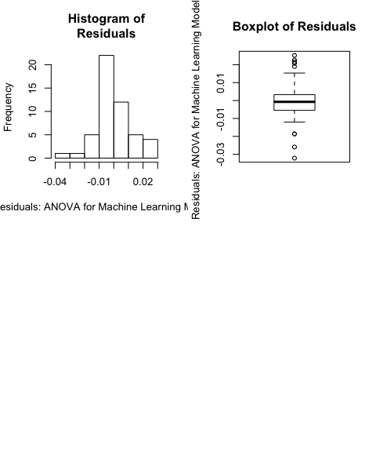

shapiro.test(ml_res)

##   
## Shapiro-Wilk normality test  
##   
## data: ml_res  
## W = 0.98548, p-value = 0.7921

In qqplot not all points are close to the expected line, indicative of some departure from normality and P value for Shapiro Wilks test is high (P=0.7921) so there is normality observed here. Next we check for equality of variance of residuals.

#Check for equality of variance  
plot(ml_res,ml_pre,xlab = "Residuals",ylab = "Predicted Values")

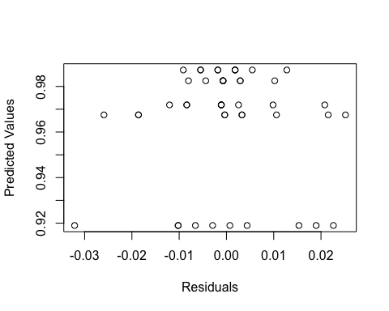

bartlett.test(accuracy ~ ml_algorithm,data=models_df)

##   
## Bartlett test of homogeneity of variances  
##   
## data: accuracy by ml_algorithm  
## Bartlett's K-squared = 4.7431, df = 4, p-value = 0.3147

leveneTest(ml_anova)

## Levene's Test for Homogeneity of Variance (center = median)  
## Df F value Pr(>F)   
## group 4 0.7174 0.5845 *  
## 45   
## ---  
## Signif. codes: 0 '***' 0.001 '**' 0.01 '*' 0.05 '.' 0.1 ' ' 1

Plot of residuals against predicted values does not show any unusual pattern (funneling or bow shape). As normality was valid, Bartlett test results are reliable. Bartlett test lead to high P-value (P=0.3147), indicating equality of variance in residuals across factor levels (homogeneity). Levene’s test also leads to the similar result but with slightly higher p-value (p = 0.5845).

Finally, as the order experiment was random with reference to each factor level setting, independence of errors can be assumed. All underlying anova assumptions are satisfied.

# 7. Comparing Models

tapply(models_df$accuracy,models_df$ml_algorithm, mean)

## logReg LDA RTree nBayes SVM   
## 0.9872263 0.9718978 0.9675182 0.9189781 0.9824818

tapply(models_df$accuracy,models_df$ml_algorithm, sd)

## logReg LDA RTree nBayes SVM   
## 0.006262549 0.009586807 0.016983770 0.016394044 0.004804968

**Results of analysis of mean are reported as follows:** Mean (standard deviation) of machine learning models for logistic regression, linear discriminant analysis, regression tree, naive bayes and support vector machine are 0.989(0.006), 0.9777(0.010), 0.9660(0.0115), 0.9124(0.0122), 0.985(0.0085) respectively.

# 8. Multiple Comparisons

## Fishers Least Significant Difference Test (Fisher’s LSD)

library(agricolae)  
MComLSD=LSD.test(ml_anova,"ml_algorithm");MComLSD

## $statistics  
## MSerror Df Mean CV t.value LSD  
## 0.0001422854 45 0.9656204 1.235304 2.014103 0.01074427  
##   
## $parameters  
## test p.ajusted name.t ntr alpha  
## Fisher-LSD none ml_algorithm 5 0.05  
##   
## $means  
## accuracy std r LCL UCL Min Max  
## LDA 0.9718978 0.009586807 10 0.9643005 0.9794952 0.9598540 0.9927007  
## logReg 0.9872263 0.006262549 10 0.9796289 0.9948236 0.9781022 1.0000000  
## nBayes 0.9189781 0.016394044 10 0.9113808 0.9265754 0.8868613 0.9416058  
## RTree 0.9675182 0.016983770 10 0.9599209 0.9751156 0.9416058 0.9927007  
## SVM 0.9824818 0.004804968 10 0.9748844 0.9900791 0.9744526 0.9927007  
## Q25 Q50 Q75  
## LDA 0.9653285 0.9708029 0.9735401  
## logReg 0.9826642 0.9872263 0.9890511  
## nBayes 0.9096715 0.9178832 0.9315693  
## RTree 0.9534672 0.9689781 0.9762774  
## SVM 0.9817518 0.9817518 0.9844891  
##   
## $comparison  
## NULL  
##   
## $groups  
## accuracy groups  
## logReg 0.9872263 a  
## SVM 0.9824818 ab  
## LDA 0.9718978 bc  
## RTree 0.9675182 c  
## nBayes 0.9189781 d  
##   
## attr(,"class")  
## [1] "group"

## Tukey’s Studentised Range Test

MComTukey=HSD.test(ml_anova,"ml_algorithm");MComTukey

## $statistics  
## MSerror Df Mean CV MSD  
## 0.0001422854 45 0.9656204 1.235304 0.01515777  
##   
## $parameters  
## test name.t ntr StudentizedRange alpha  
## Tukey ml_algorithm 5 4.018417 0.05  
##   
## $means  
## accuracy std r Min Max Q25 Q50  
## LDA 0.9718978 0.009586807 10 0.9598540 0.9927007 0.9653285 0.9708029  
## logReg 0.9872263 0.006262549 10 0.9781022 1.0000000 0.9826642 0.9872263  
## nBayes 0.9189781 0.016394044 10 0.8868613 0.9416058 0.9096715 0.9178832  
## RTree 0.9675182 0.016983770 10 0.9416058 0.9927007 0.9534672 0.9689781  
## SVM 0.9824818 0.004804968 10 0.9744526 0.9927007 0.9817518 0.9817518  
## Q75  
## LDA 0.9735401  
## logReg 0.9890511  
## nBayes 0.9315693  
## RTree 0.9762774  
## SVM 0.9844891  
##   
## $comparison  
## NULL  
##   
## $groups  
## accuracy groups  
## logReg 0.9872263 a  
## SVM 0.9824818 ab  
## LDA 0.9718978 b  
## RTree 0.9675182 b  
## nBayes 0.9189781 c  
##   
## attr(,"class")  
## [1] "group"

## Duncan’s Test

#Use first treatment(alphanumerically)as control  
library(multcomp)

MComScheffe=glht(ml_anova,Linfct=mcp(Treatment="Dunnett"))  
summary(MComScheffe)

##   
## Simultaneous Tests for General Linear Hypotheses  
##   
## Fit: aov(formula = accuracy ~ ml_algorithm, data = models_df)  
##   
## Linear Hypotheses:  
## Estimate Std. Error t value Pr(>|t|)   
## (Intercept) == 0 0.987226 0.003772 261.720 < 0.001 ***  
## ml_algorithmLDA == 0 -0.015328 0.005335 -2.873 0.02315 *   
## ml_algorithmRTree == 0 -0.019708 0.005335 -3.694 0.00252 **   
## ml_algorithmnBayes == 0 -0.068248 0.005335 -12.794 < 0.001 ***  
## ml_algorithmSVM == 0 -0.004745 0.005335 -0.889 0.80710   
## ---  
## Signif. codes: 0 '***' 0.001 '**' 0.01 '*' 0.05 '.' 0.1 ' ' 1  
## (Adjusted p values reported -- single-step method)

## Pairwise T-tests using Bonferroni and Holm

accuracy=models_df$accuracy  
ml_algorithm=models_df$ml_algorithm  
  
MComBonferroni=pairwise.t.test(accuracy,ml_algorithm,p.adjust="bonferroni");MComBonferroni

##   
## Pairwise comparisons using t tests with pooled SD   
##   
## data: accuracy and ml_algorithm   
##   
## logReg LDA RTree nBayes   
## LDA 0.0618 - - -   
## RTree 0.0059 1.0000 - -   
## nBayes 1.4e-15 6.7e-12 9.2e-11 -   
## SVM 1.0000 0.5337 0.0740 1.7e-14  
##   
## P value adjustment method: bonferroni

attach(models_df)  
MComPairwise=pairwise.t.test(accuracy,ml_algorithm);MComPairwise

##   
## Pairwise comparisons using t tests with pooled SD   
##   
## data: accuracy and ml_algorithm   
##   
## logReg LDA RTree nBayes   
## LDA 0.0309 - - -   
## RTree 0.0036 0.7570 - -   
## nBayes 1.4e-15 5.3e-12 6.4e-11 -   
## SVM 0.7570 0.1601 0.0309 1.5e-14  
##   
## P value adjustment method: holm

# RESULT PLOTTING

library(ggplot2)  
p = ggplot(models_df, aes(ml_algorithm, accuracy, fill=ml_algorithm))  
p + geom_boxplot(width=0.5) + geom_jitter(width = 0.01, colour = 'lightsteelblue4', alpha=0.3) + scale_fill_brewer(palette = "Spectral") + ggtitle("Boxplot of Machine Learning Algorithm's Accuracy")

